**Department of Electrical Engineering and   
Computer Science**

**Faculty Member:** Dr. Shakeel Alvi **Dated:** 3/02/2022

**Semester:** 4th **Section:** BEE 12C

**EE-215:** **Electronic Devices And Circuits**

Lab 5: Application of Diode (Limiter Circuit)

**Group Members**

|  |  |  |  |  |
| --- | --- | --- | --- | --- |
| **PLO4/CLO4** | | **PLO5/CLO5** | **PLO8/CLO6** | **PLO9/CLO7** |
| **Name** | **Reg. No** | **Viva /Quiz / Lab Performance**  **5 marks** | **Analysis of Data in Lab Report**  **5 marks** | **Modern Tool Usage**  **5 marks** | **Ethics and Safety**  **5 marks** | **Individual and Team Work**  **5 marks** |
| **Tariq Umar** | **334943** |  |  |  |  |  |
| **Saad Bakhtiar** | **341150** |  |  |  |  |  |
|  |  |  |  |  |  |  |
|  |  |  |  |  |  |  |
|  |  |  |  |  |  |  |

# Laboratory Experiment # 5

## Objectives

The primary purpose of this lab is to develop a working knowledge of diode. Diodes can be used in variety of circuits for various applications such as clippers/clampers and voltage regulators.

## Equipment

The following will be required in this lab experiment:

* PN Diode
* Oscilloscope
* Function Generator
* Resistors
* Capacitors
* Power Supply

## Introduction

In electronics, a clipper is a device designed to prevent the output of a circuit from exceeding a predetermined voltage level without distorting the remaining part of the applied waveform.

A clipping circuit consists of linear elements like resistors and non-linear elements like junction diodes or transistors, but it does not contain energy-storage elements like capacitors. Clipping circuits are used to select for purposes of transmission, that part of a signal wave form which lies above or below a certain reference voltage level.

Thus a clipper circuit can remove certain portions of an arbitrary waveform near the positive or negative peaks. Clipping may be achieved either at one level or two levels.

## Conduct of Lab

The students are required to work in groups of four; each student must attempt to understand and use the laboratoy set-up and conduct at least one or two parts of the requirement experimentation.The lab engineer will be available to assist the students. In case some aspect of the lab experiment is not understood the students are advised to seek help from the teacher, the lab attendent or the assigned Lab Engineer.

# Exercises

## Part A (Simulation)

This exercise is on another application of diode, which is known as limiter. It serves the purpose of clipping off peaks and is also known as clipper. The first part of this exercise is simulation on PSpice.

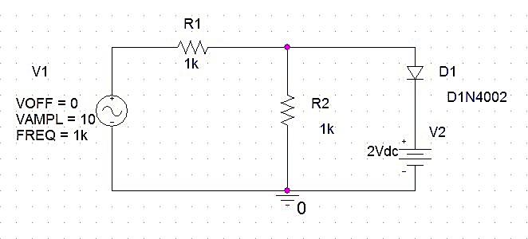

Figure

* Since we need to observe the VIN vs. VOUT graph, we simulate our circuit using the following Time Domain settings.

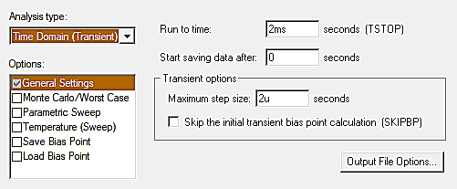

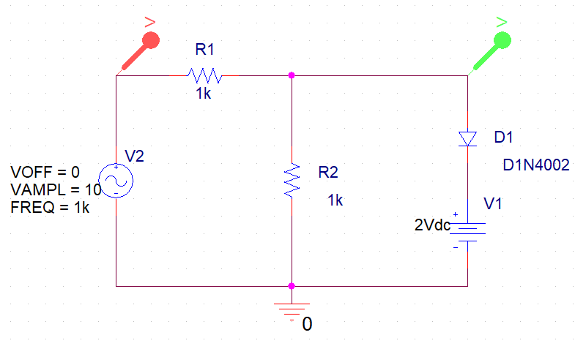

Figure 2

**VIN vs. VOUT : At 2 Vdc**

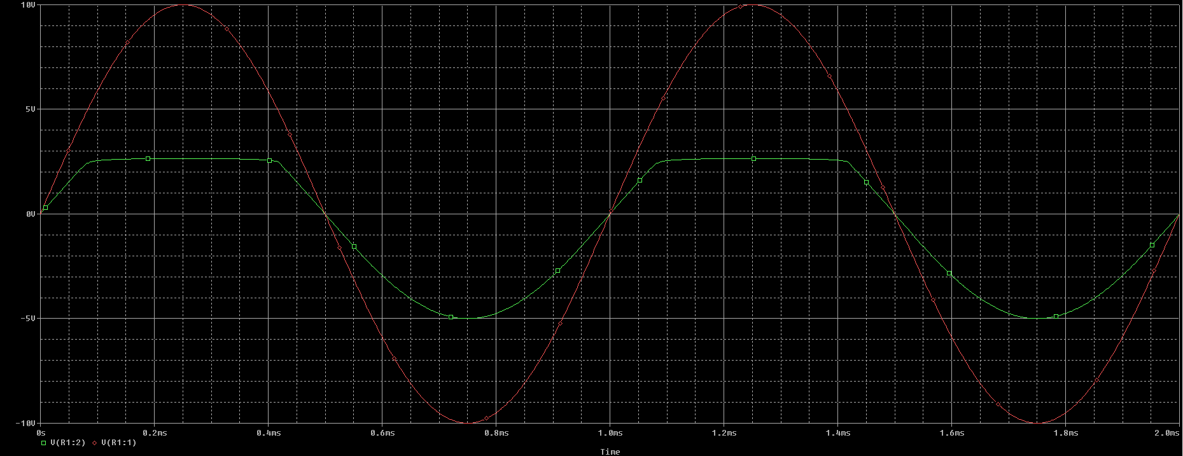

**VIN vs. VOUT : At 5 Vdc**

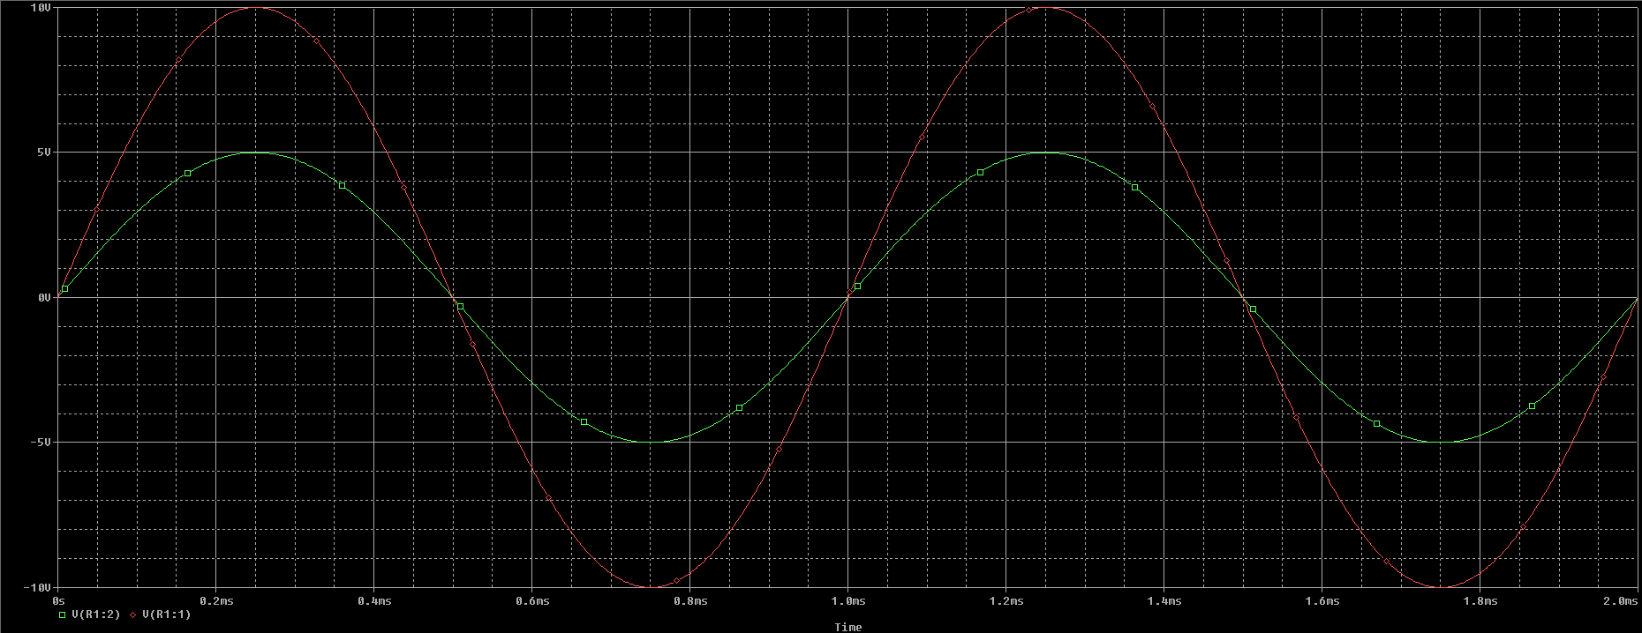

**VIN vs. VOUT : Reversed Configuration**

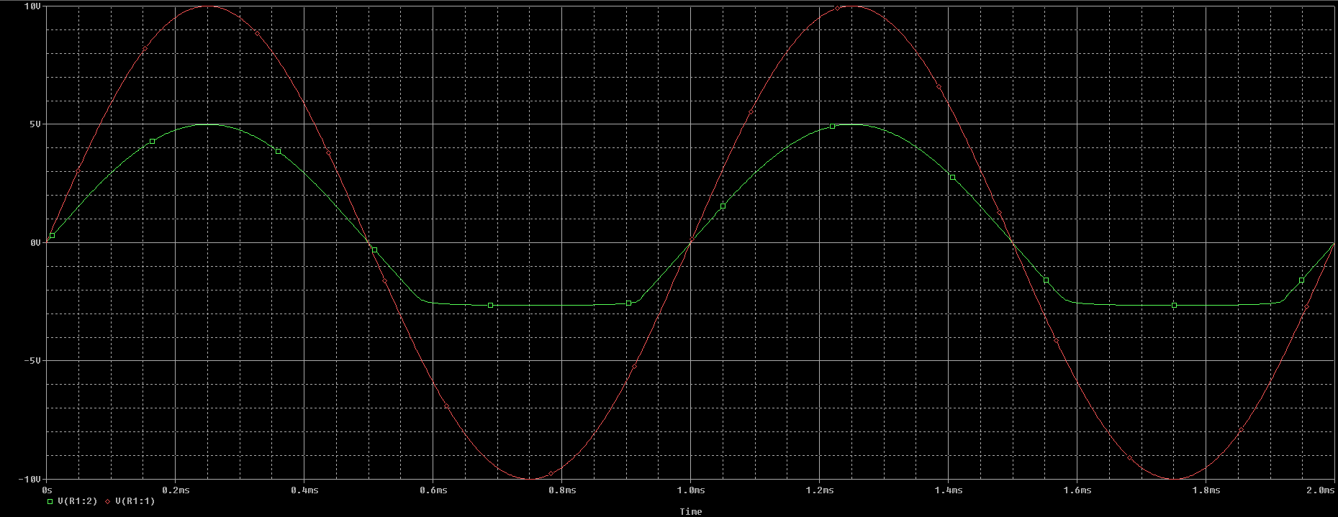

**DC Sweep Analysis**

In order to perform appropriate DC Sweet Analysis and plot transfer characteristic curves, we have to swap out our VSIN voltage source with a DC voltage source.

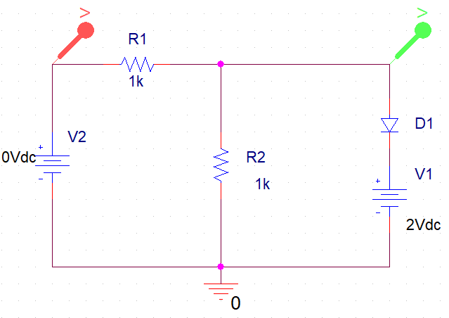

Simulation Circuit

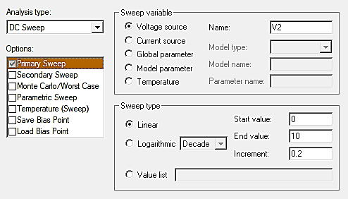

Simulation Settings

**VIN vs. VOUT**

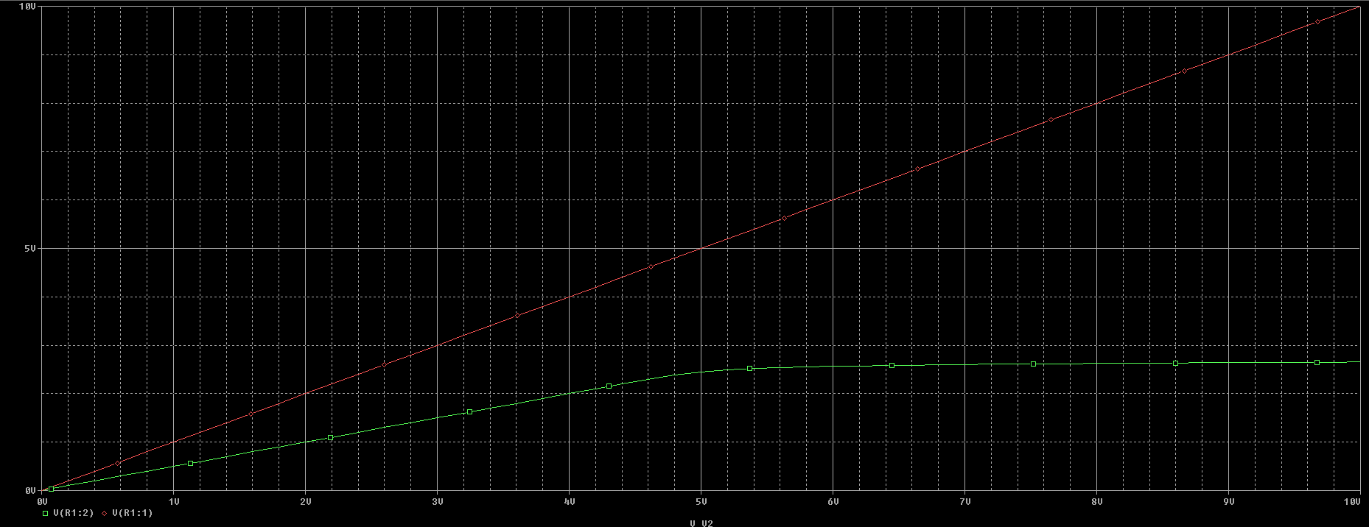

## Observations/Measurements

Answer the following questions:

* What happens when you change the value of the DC source in the circuit? Explain.

**Answer**: Change in the DC Value of the source results in the change of where the circuit clips.

* If value of DC source exceeds the peak value of VSIN what do you think should happen? Demonstrate by the help of a graph drawn in OrCad.

**Answer**: During +ive half cycle, in this case, the diode never turns on since VSIN is less than Voltage of DC Source + Voltage drop across Diode. While during negative half cycle diode acts as an open circuit.

* Attach graphs at Vdc = 2V, 5V, 8V and 10V in your lab report. Explain the difference observed.

At 2V, 5V, 8V and 10V (*Sequentially*)





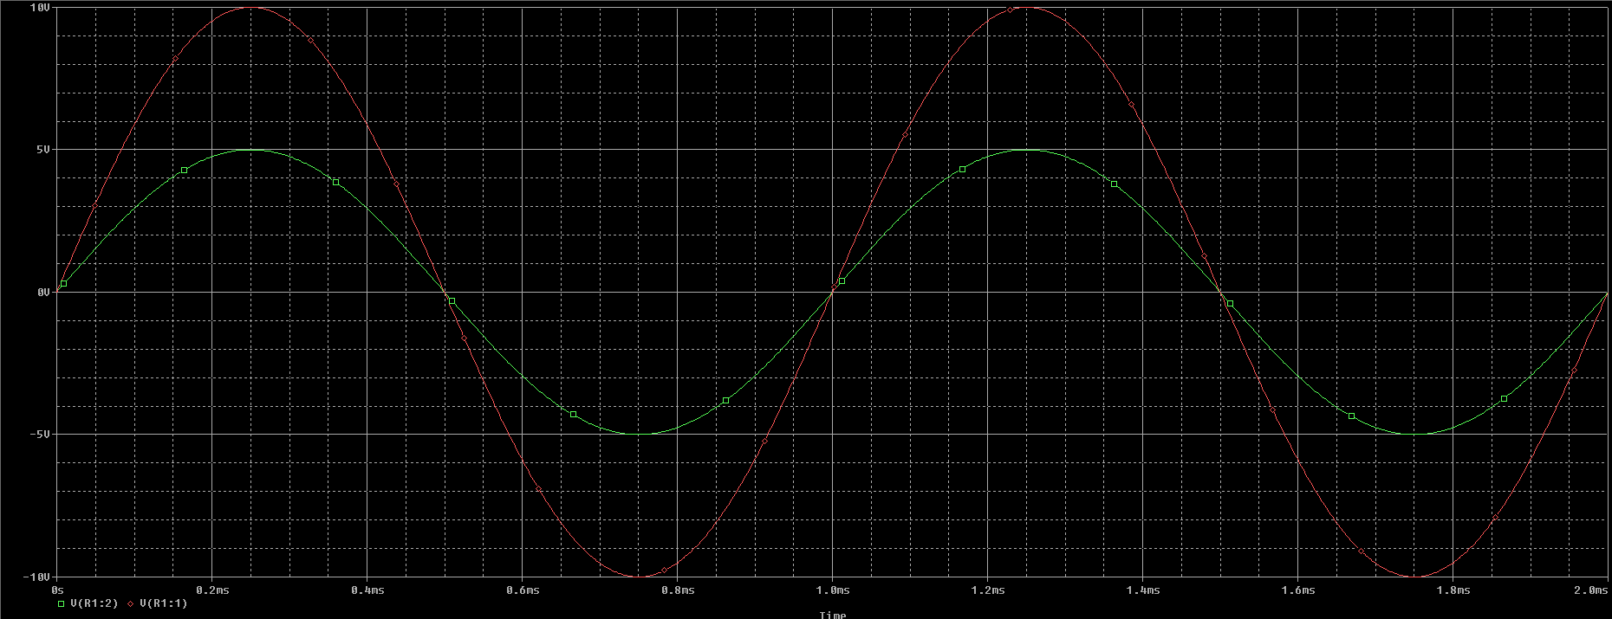



* Explain the transfer characteristic curve of the limiter circuit.

**Answer**: When we change the value from 2V up to 5V the clipping interval decreases. Further increase in V DC leads to clipping almost disappearing.

* Attach the transfer characteristic curve taken at Vdc = 2V, 5V, 8V and 10V. What difference do you observe? Why do the differences occur?

At 2V, 5V, 8V and 10V (*Sequentially*)

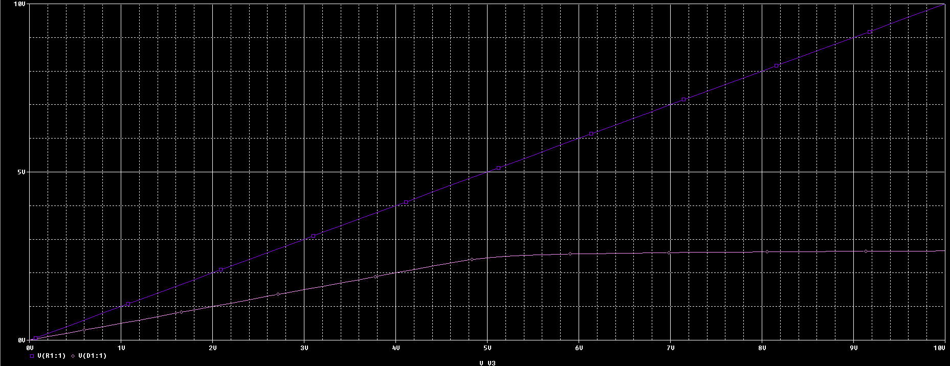

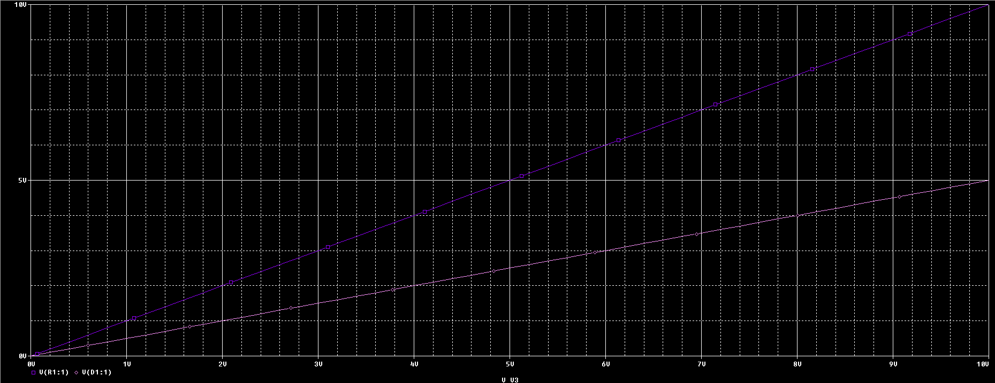





**Answer**: We observe a variance in clipping levels for different values of DC voltage source used; Due to the change in value of VDC in series with the Diode, we have different a voltage drop across the whole branch (the diode and the voltage source) and hence a different characteristic curve.

* Theoretically calculate the point where Vout becomes constant in the transfer characteristics curve? Compare it with the results obtained via simulations. Explain the difference if any.

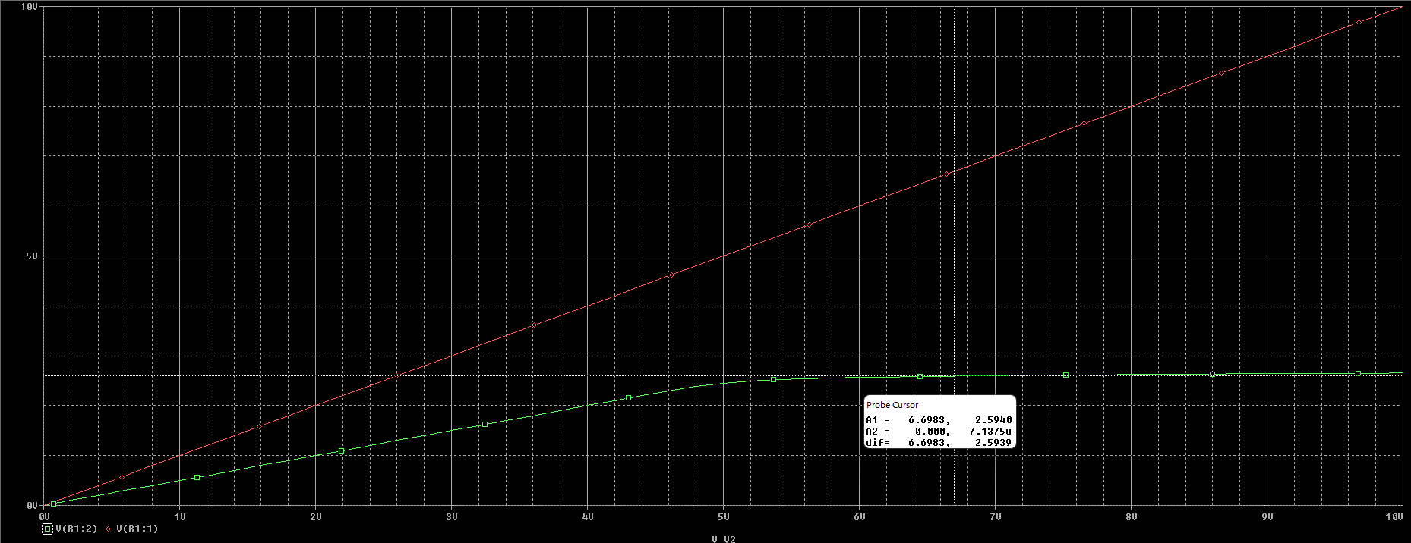

**Simulated Value**

**VOUT** = **2.5940V**

**Theoretical Value**

**VOUT** = VD + 2V ; VD = 0.7V (for silicon - based diodes)

**VOUT** = 0.7 + 2V = **2.7V**

**Answer**: Theoretical calculations assume a perfect voltage drop of 0.7V across the diodes whereas in simulation softwares, the factor of tolerance is also put into effect which results in theoretical discrepancies.

## Part B (Simulation)

* In this part of the exercise, you have to simulate the circuit provided in figure 1 but it should clip positive peak at +1.5V and negative peak at – 0.2v. The procedure for doing the exercise the same as described in part A of exercise 2.

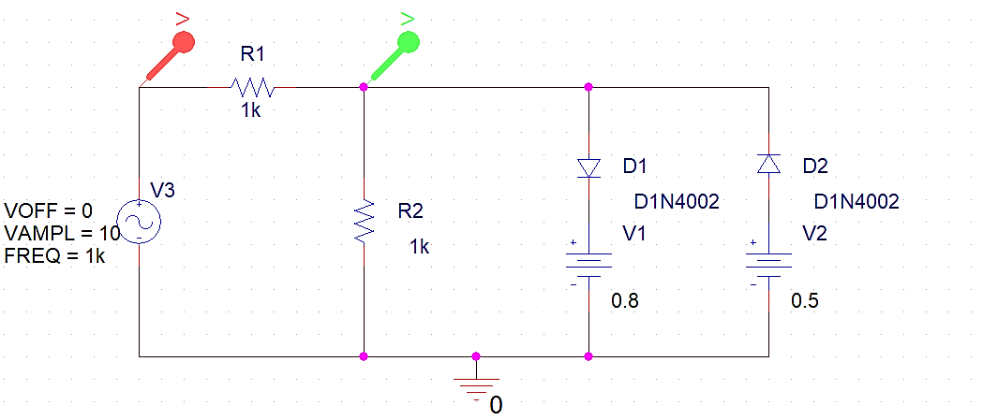

Simulation Circuit

**VIN vs. VOUT**

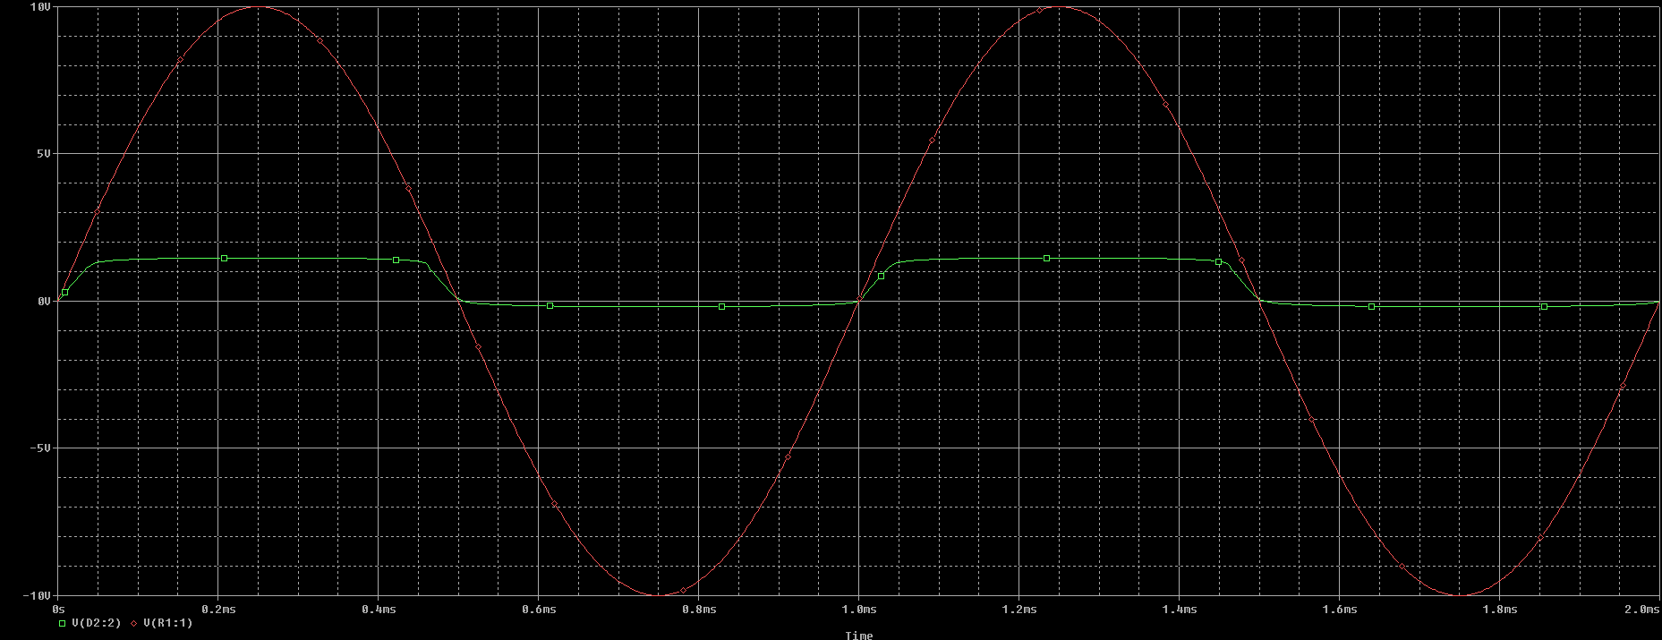

* Explain what differences do you observe with respect to the limiter in part A. Why do these differences occur?

**Answer**: These differences occur since we have connected two diodes with DC voltage sources parallel to each other with opposite polarity. During the positive cycle one acts as short circuit and clips the output wave at +y axis while during the negative interval the other diode clips the output wave at –y axis.

## Part C (Implementation)

The following procedure should be adopted while practical implementation of the circuit given in figure 1.

* Patch the circuit as shown in the figure.
* Try to observe the input and output curves on a dual channel oscilloscope.
* Save your results and add them to your report.

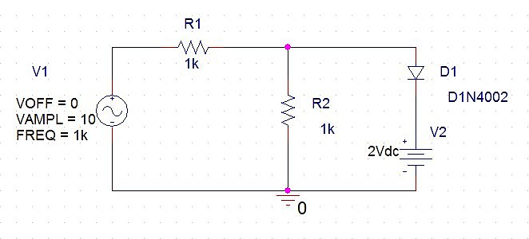

Figure

**Output Voltage: With Real Time DC Voltage Variation**



We can see clipping levels to decrease as the DC voltage of the source in series with the diode is increased, as it directly affects the voltage at which our transfer characteristic curve becomes constant.

**Output Voltage: With Real Time DC Voltage Variation**

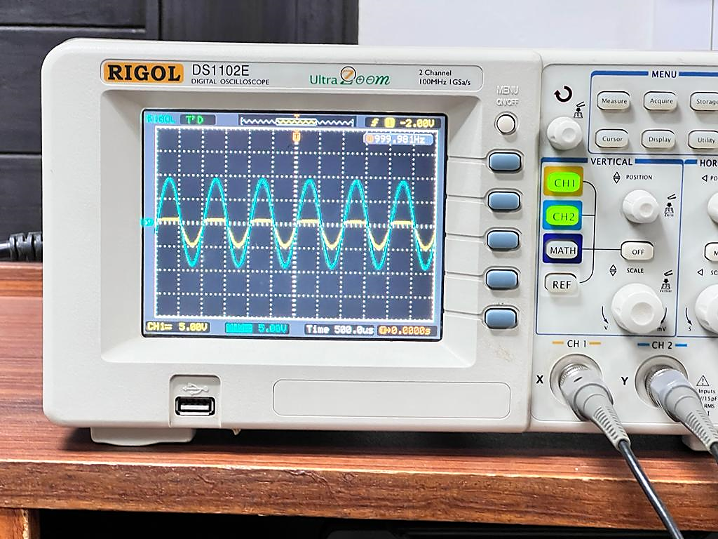

**Output Voltage: Implementation of Task B**

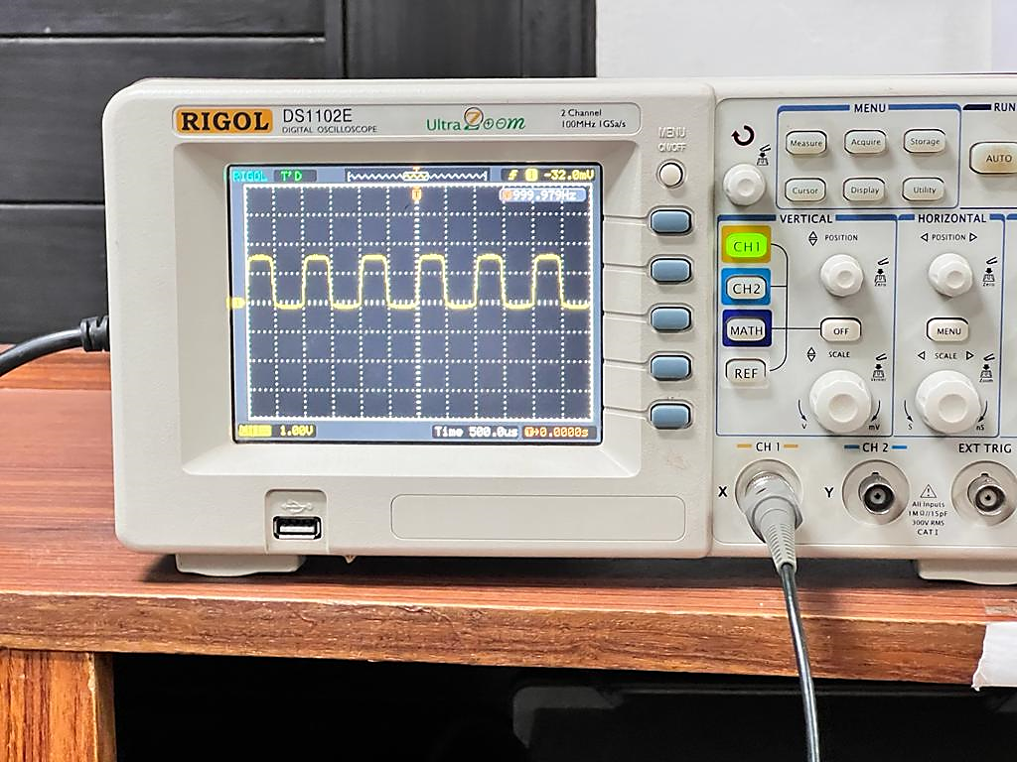

# Conclusion

After performing this lab, we have achieved the following goals;

* Expanded on our understanding of a fundamental electronic component; diode
* Built a circuit to demonstrate a real-life application of diode; clipping
* Calculated the voltage at which output voltage VOUT, that is across the Diode and the DC voltage source, becomes constant, both theoretically and through simulation
* Performed clipping at both positive and negative peaks using two diodes in parallel with each other